1. 
2. In Java, we have 3 kinds of exceptions.
3. 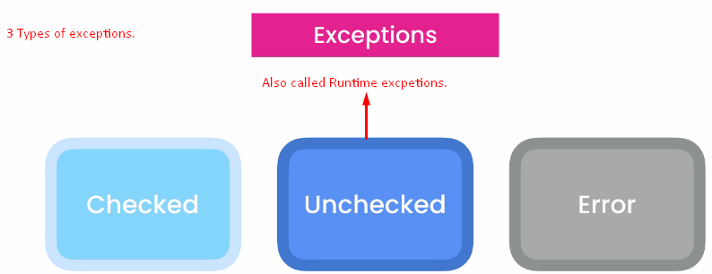
4. **Checked** **Exception**: Checked exceptions are exceptions that we developers should anticipate and handle properly.
   1. **For example**: We want to read data from a file. But if the file doesn’t exist.
   2. But the developers anticipate and handle this edge case. But the java compiler forces us to handle such case in advance so called checked exception.
   3. 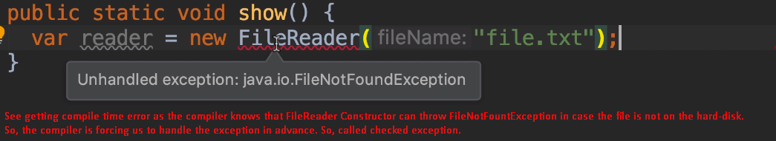
5. **Unchecked Exception**: Also called **Runtime Exception**.
   1. Not checked by the compiler at the compile time so called unchecked exception. Example 🡺 NullPointerException.
   2. 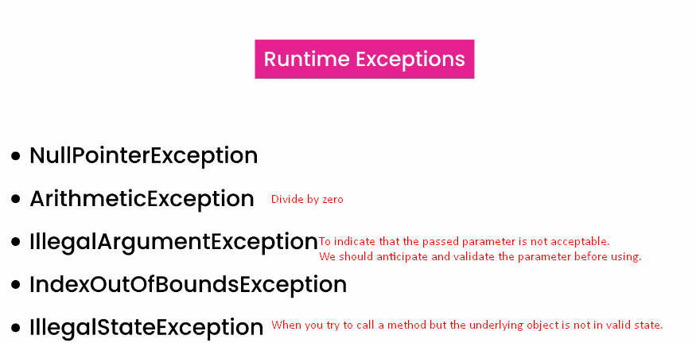
6. **Error**: Kind of exception which indicates error external to our app.
   1. StackOverflowError, OutOfMemoryError.
   2. If java virtual machine runs out of memory, there is nothing we can do about it.
   3. We should not handle such error.
   4. Such error can occur due to programming error like infinite recursion.